Follow these steps to download crash data from ODOT’s TDS Crash Reports web tool, and import the data to Excel using the Decode XML version of the CDS510. The XML extract replaced the MS Access Decode DB CDS510 available from the web tool as of 4/13/2023.

1. DOWNLOAD a “Decode XML CDS510” DATA EXTRACT
2. Click the TDS Crash Reports web tool **HELP** link, and follow the instructions for how to query data from the desired tab: Highway, Local Roads, or All Jurisdictions.
3. Afer you’ve selected your query parameters, scroll to the **Select a Date Range** pane, and input a range no greater than 5 years.
4. Scroll to the “**Select a Data Extract”** pane near the bottom of the screen, then press the **Decode XML CDS510** button. A **decode.zip** file will be generated.

1. Save the **decode.zip** file where you want to store your data tables.They may be very large, depending on your query.
2. Recommended: Re-name the folder in a way that describes the data you downloaded; i.e. Pacific Hwy 1 (I-5) Crashes MP 0.00-25.00_2016-2020
3. Extract the zipped file contents. This will open a subfolder containing .**xsd** *(structure)* and .**xml** *(data)* tables.
4. IMPORT the DOWNLOADED FILES to MS EXCEL
5. Open a new MS Excel workbook.
6. Click the **Developer** menu to open its ribbon.



* 1. If **Developer** isn’t availabe from your menu bar:
     1. Click **File**
     2. Click **Options**
     3. Click **Customize Ribbon**
        1. Pull down the **Choose commands from:** selection box, then select **All Commands**
        2. Scroll down and click **Developer**, then click the **Add>>** button
        3. Click **OK**

1. Graphical user interface, diagram

   Description automatically generated with medium confidence**Map** the **.xsd** file for the desired table (i.e., CRASH), before attempting to import the data.
   1. From the **Developer** ribbon, click the **Source** icon.
   2. The **XML Source** navigation pane opens at the right margin of the Excel worksheet.

* 1. Graphical user interface, text, application, Word

     Description automatically generatedClick the **XML Maps** button  at the bottom of the **XML Source** pane. This will open the XML Maps dialog window.
  2. In the **dialog window**, click the **Add** button.
  3. Navigate to your **decode.zip** downloaded file.

1. **Import** the desired .**xsd** file (i.e., **CRASH**.xsd) to your worksheet.
   1. Graphical user interface, text, application, email

      Description automatically generatedDouble-click the **CRASH.xsd** file. This will re-open the “XML Maps” dialog window and assign a “**Root Map**” name to your table.
   2. **Re-name** “Root_Map" to **CRASH_Map**, then click OK. The table is **mapped** to the **XML Source** navigation pane.
2. **Load** the table’s **column names** to your worksheet.
   1. Click and drag the “**Root**” table to cell **A1** of the Excel spreadsheet. This loads your table’s **column names** into your worksheet.

1. Import the corresponding .**xml** file (**CRASH**.xml)to your worksheet.

* 1. Click **once** in **cell** **A2** (column A, row 2).
  2. Click the **Developer** menu again, then...
  3. Click the **Import** icon.
  4. **Double-click** (or click once then click the “**Import**” button) the **.xml** file that matches the .xsd file you just imported.
  5. This loads the xml **data** into your worksheet.

**Note**: If you get an XML Import Error saying “some data was imported as text”, click OK. We’ve preserved the schema for text fields that contain leading zeros, for accurate reporting.

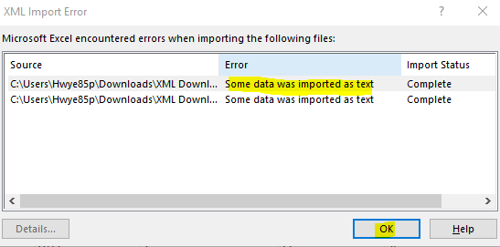

1. **Repeat** Section **II, Steps 3** through **6** above to import the Vehicle and Participant “child” tables related to the Crash table you just downloaded, and any desired Lookup tables.

The three data tables, and one crash data cross-reference table, are listed below. All others are “lookup” tables.

* + CRASH
  + VHCL
  + PARTIC
  + CRASH_KEY_XREF

Note: The **CRASH_KEY_XREF** table contains the record ID’s that correctly associates:

* every vehicle to the correct crash;
* every vehicle occupant to the correct vehicle and crash;
* every involved non-occupant (i.e. pedestrian, bicyclist, etc.) to the correct crash.

This table is useful for verifying your results of if you perform complex filtering.

*End of Import Steps*